**Title Here, Calibri Bold, 20pt Title Case, Aligned Left**

**Subtitle here, calibri bold, 14pt sentence case, aligned left**

**First Author1, Second Author2,and Third Author3 (Calibri Bold 11pt., aligned left)**

1Full affiliation of first author, including country (in English, Calibri 9pt, aligned left) and email

2Full affiliation of second author, including country (in English) and email

3Indicate each author’s affiliation in the same way (in English)

ABSTRACT

Text: Calibri 10pt justified; 13pt line spacing, 6pt after paragraph. The abstract should outline the purpose of the article, research methods, data, and main results. Lorem ipsum dolor sit amet, consectetur adipiscing elit. Morbi vulputate porta tristique. Suspendisse dictum iaculis molestie. Lorem ipsum dolor sit amet, consectetur adipiscing elit. Vivamus id congue metus. Aliquam commodo tristique dictum. Aliquam dapibus sem eu semper vulputate. Sed eget enim tellus. Vestibulum laoreet, elit id condimentum euismod, justo ex ullamcorper ipsum, at vehicula neque neque non massa. Phasellus gravida felis justo, ac suscipit leo finibus in.

Curabitur eget arcu felis. Sed elementum tincidunt lobortis. Nulla nisl nibh, semper non lacus vitae, malesuada fermentum diam. Ut eu ipsum non augue tristique eleifend. Nam auctor erat eu augue faucibus tincidunt. Ut cursus odio id placerat pretium. Nam condimentum quis tortor non placerat. Praesent libero purus, interdum eu risus quis, maximus maximus nisi.

KEYWORDS

Keyword 1, Keyword 2, Keyword 3 (max 5 keywords in English)

**1. INTRODUCTION**

Text: Calibri 11pt justified; 16pt line spacing, 6pt after paragraph.[1] The article must be divided into chapters. It is recommended to adjust the body of the paper to the common organization structure of scientific papers – ***IMRaD (Introduction, Methods, Results and Discussion).***

Lorem ipsum dolor sit amet, consectetur adipiscing elit. Nunc cursus nunc dui, quis tincidunt nisl pellentesque in. Nunc pellentesque arcu nec consequat lobortis. Sed quis malesuada magna, at rutrum justo. Donec quis nisl est. Suspendisse viverra molestie metus. Nullam eget dui a lacus pharetra maximus. Nulla vestibulum eu lectus sit amet condimentum. Ut feugiat porttitor quam. Pellentesque aliquam turpis eu maximus auctor. Nullam eget metus vel dui tristique consequat non ac nisi.

Suspendisse potenti. Nulla nec rutrum tortor. Nulla dui sapien, cursus sed iaculis nec, elementum vel augue. Donec sit amet dui pulvinar, ultricies urna eu, gravida est. In ullamcorper, augue non egestas mattis, odio lacus rutrum felis, non ultrices diam sapien non sem. Etiam auctor facilisis euismod. Ut tempus nisi ut laoreet pharetra.

Cras faucibus in purus quis aliquam. Orci varius natoque penatibus et magnis dis parturient montes, nascetur ridiculus mus. Nulla dictum varius metus. Ut id risus at dui luctus porta ut ut ante. Aenean bibendum scelerisque odio at efficitur. Cras nec mi at neque viverra pellentesque.

**2. SUBTITLE UPPERCASE**

**2.1. Second level subtitle (Calibri Bold 11pt)**

Text: Calibri 11pt justified; 16pt line spacing, 6pt after paragraph. Lorem ipsum dolor sit amet, consectetur adipiscing elit. Nunc cursus nunc dui, quis tincidunt nisl pellentesque in. Nunc pellentesque arcu nec consequat lobortis. Sed quis malesuada magna, at rutrum justo. Donec quis nisl est. Suspendisse viverra molestie metus. Nullam eget dui a lacus pharetra maximus. Nulla vestibulum eu lectus sit amet condimentum.

*Figure 1: Descriptive title (Calibri italic 10pt, centered)*

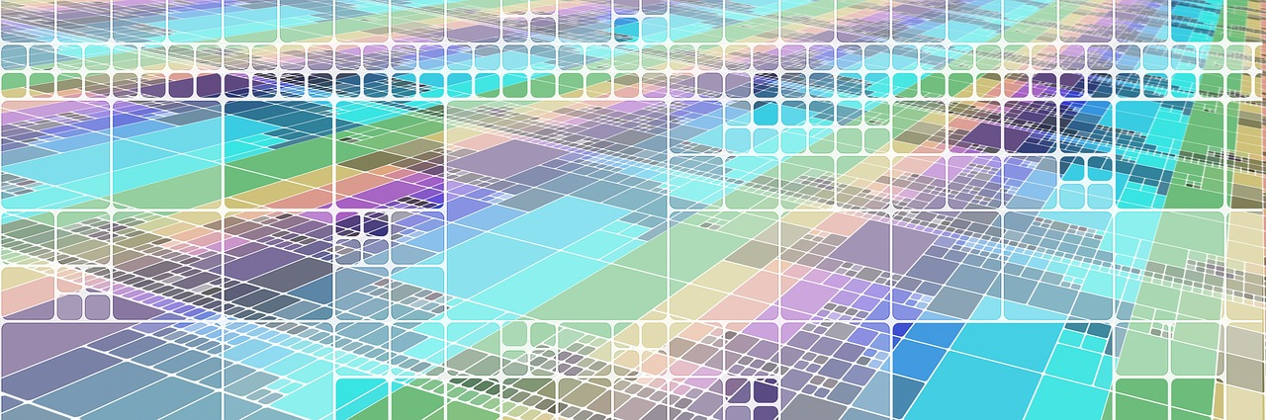

*Source: Calibri italic 8pt, aligned left*

Suspendisse potenti. Nulla nec rutrum tortor. Nulla dui sapien, cursus sed iaculis nec, elementum vel augue. Donec sit amet dui pulvinar, ultricies urna eu, gravida est. In ullamcorper, augue non egestas mattis, odio lacus rutrum felis, non ultrices diam sapien non sem. Etiam auctor facilisis euismod. Ut tempus nisi ut laoreet pharetra. Praesent elementum mauris neque, vitae commodo metus finibus id. Suspendisse sagittis aliquam dui a aliquet. Cras faucibus in purus quis aliquam. Orci varius natoque penatibus et magnis dis parturient montes, nascetur ridiculus mus. Nulla dictum varius metus. Ut id risus at dui luctus porta ut ut ante. Aenean bibendum scelerisque odio at efficitur.

(…)

Tables and figures must be numbered and must always be referred to in the text. Tables and Figures should be referred to as Tab. 1 and Fig. 1.

*Table 1: Descriptive title (Calibri italic 10pt, centered)*

|  |  |  |
| --- | --- | --- |
| Calibri 10pt | Calibri 10pt | Calibri 10pt |
| Calibri 10pt | Calibri 10pt | Calibri 10pt |
| Calibri 10pt | Calibri 10pt | Calibri 10pt |
| Calibri 10pt | Calibri 10pt | Calibri 10pt |

*Source: Calibri italic 8pt, aligned left*

**Equations**

Equations (to be referred to as: Eq. 1, Eq. 2,...) should be centred, denoted by numbers in round parentheses and transformed by the equation conversion manager. **Do not use Print Screen or jpg format**. For example:

 (1)

### ACKNOWLEDGMENT

Text: Calibri 10pt justified; 13pt line spacing. Lorem ipsum dolor sit amet, consectetur adipiscing elit. Morbi vulputate porta tristique. Suspendisse dictum iaculis molestie. Lorem ipsum dolor sit amet, consectetur adipiscing elit. Vivamus id congue metus. Aliquam commodo tristique dictum. Aliquam dapibus sem eu semper vulputate. Sed eget enim tellus. Vestibulum laoreet, elit id condimentum euismod, justo ex ullamcorper ipsum, at vehicula neque neque non massa. Phasellus gravida felis justo, ac suscipit leo finibus in.

REFERENCES

References in text should have this form (surname, year).

For example:

1 author: (Smith, 2012)

1 author and the same year of publication: (Smith 2012, A), (Smith, 2012, B)

2 authors: (Smith & Jones, 2014)

3 authors: (Brown et al., 2012)

For direct citations, please indicate the page number (if applicable): (Smith, 2012, p. 34).

For each work shown in the list of references there must be a reference in the text.  All citations in the text and all references must follow the American Psychological Association (APA) style (7th edition).

**Book**

Author, A. A. (Year of publication). Title of work: Capital letter also for subtitle. Publisher Name. DOI (if available)

James, A., & Brown, R. (1999). *Networks for Optimization and Processing*. Wiley.

**Article or chapter in an edited book**

Author, A. A., & Author, B. B. (Year of publication). Title of chapter. In E. E. Editor & F. F. Editor (Eds.), Title of work: Capital letter also for subtitle (pp. pages of chapter). Publisher. DOI (if available)

Bigo, D. (2006). Security, exception, ban and surveillance. In D. Lyon (Ed.), *Theorizing surveillance: The Panopticon and beyond* (pp. 46-68). Willan.

**Article in periodical**

Author, A. A., Author, B. B., & Author, C. C. (Year). Title of article. Title of Periodical, volume number(issue number), pages. https://doi.org/xx.xxx/yyyy

Wang, Y. (2021). An improved machine learning and artificial intelligence algorithm for classroom management of English distance education. *Journal of Intelligent and Fuzzy Systems*, *40*(2), 3477-3488. <https://doi.org/10.3233/jifs-189385>

**Electronic Sources**

Lastname, F. M. (Year, Month Date). Title of page. Site name. URL

Gates, B. (2023, March 21). *The age of AI has begun*. Gatesnotes. <https://www.gatesnotes.com/The-Age-of-AI-Has-Begun>

**For more information and further examples:**

[*http://www.apastyle.org/*](http://www.apastyle.org/)

[*https://owl.purdue.edu/owl/research_and_citation/apa_style/apa_formatting_and_style_guide/index.html*](https://owl.purdue.edu/owl/research_and_citation/apa_style/apa_formatting_and_style_guide/index.html)

***PLEASE RENAME THE DOCUMENT BY INCLUDING THE SURNAMES OF ALL AUTHORS.***

***For example: Smith_Jones_Brown_PAPER***

1. Footnote Calibri 9 pt.